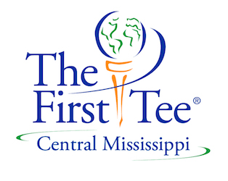

Par Car Talk Week 6

Suggested questions for an engaging recap with your child/children about today’s experience at First Tee of Central Mississippi and practice suggestions to help between classes!

Weekly Core Lesson: Finding Your Personal Par.
Weekly Healthy Habit: Friends
Weekly Golf Skill: Playing
Homework Assignment: p. 40-43 in Par Book.

Guiding Questions:

- Can you tell me what Personal Par means?
- Why is it important to have your own personal par rather than comparing yourself to others?
- What are some ways you can measure “par” other than by score?
- How does finding your personal par connect with exploring the game, respecting the rules, having fun while you learn, staying cool, and meeting and greeting with a-l-r?
- What was your biggest challenge today?
- What was your greatest achievement today?

Golf Skill Practice: This week we talked about Finding Personal Par and we played in small groups. From this playing round, your child should have noticed things they did well and things they could have improved upon. As they practice this week, they should use their resources (ex: people they can ask for help, their par book etc.) to determine what they should work on in their practice.

